CHAPTER 2 REVIEW
Measurements and Calculations
SECTION 1
SHORT ANSWER Answer the following questions in the space provided.
1. Determine whether each of the following is an example of observation and data, a theory, a hypothesis, a control, or a model.
a. A research team records the rainfall in inches
per day in a prescribed area of the rain forest.
The square footage of vegetation and relative plant density per square foot are also measured.
b. The intensity, duration, and time of day of the precipitation are noted for each precipitation episode. The types of vegetation in the area are recorded and classified.
c. The information gathered is compared with the data on the average precipitation and the plant population collected over the last 10 years.
d. The information gathered by the research team indicates that rainfall has decreased significantly. They propose that deforestation is the primary cause of this phenomenon.

2. “When 10.0 g of a white, crystalline sugar are dissolved in 100. mL of water, the solution is observed to freeze at −0.54°C, not 0.0°C. The system is denser than pure water.” Which parts of these statements represent quantitative information, and which parts represent qualitative information?

3. Compare and contrast a hypothesis with a theory.

SECTION 1 continued
4. _____ How many different variables are represented in the two graphs shown below?
a. one b. two c. three d. four
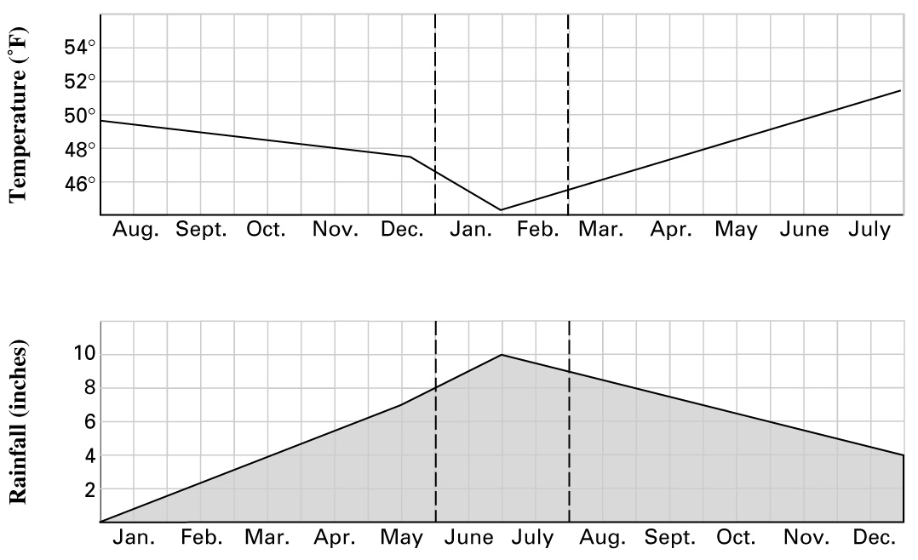

SECTION 2
SHORT ANSWER Answer the following questions in the space provided. Show all work below using CONVERSION FACTORS.
1. Complete the following conversions:
a. 100 mL = ______________________L
b. 0.25 g = ______________________cg
c. 400 cm3 = ______________________L
d. 400 cm3 = ______________________m3
SECTION 2 continued
2. Use the data found in Table 4 on page 36 of the text to answer the following questions:
a. If ice were denser than liquid water at 0°C, would it float or sink in water?
b. Water and kerosene do not dissolve readily in one another. If the two are mixed, they quickly separate into layers. Which liquid floats on top?
c. The other liquids in Table 4 that do not dissolve in water are gasoline, turpentine, and mercury. Which of these liquids would settle to the bottom when mixed with water?

3. Use the graph of the density of aluminum below to determine the approximate mass of aluminum samples with the following volumes.
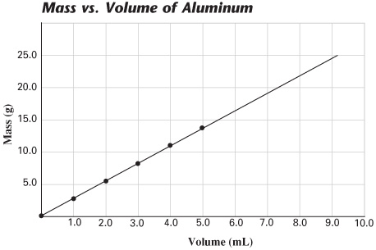
________ a. 8.0 mL
________ b. 1.50 mL
________ c. 7.25 mL
________ d. 3.50 mL
PROBLEMS Write the answer on the line to the left. Show all your work in the space provided below the problem.
5. Aluminum has a density of 2.70 g/cm3. What would be the mass of a sample whose volume is 10.0 cm3?
6. A certain piece of copper wire has mass of 2.00 g per meter. How many centimeters of the wire would be needed to provide 0.28 g of copper?

SECTION 3
SHORT ANSWER Answer the following questions in the space provided.

1. Report the number of significant figures in each of the following values:
a. 0.002 37 g
d. 64 mL
e. 1.3 × 10² cm
f. 1.30 × 10² cm

b. 0.002 037 g
c. 350. J

2. Write the value of the following operations using scientific notation.
a. 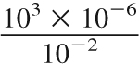
b. 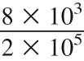
c. 3 × 10³ + 4.0 × 10⁴

3. The following data are given for two variables, A and B:
a. In the graph provided, plot the data.

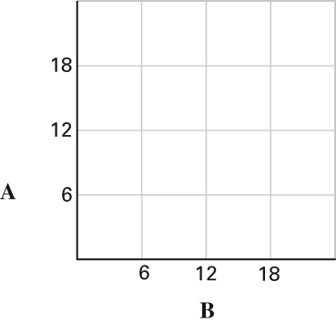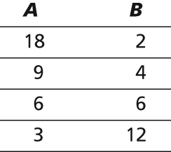

b. Are A and B directly or inversely proportional?
c. Do the data points form a straight line?
d. Which equation fits the relationship shown by the data?
= k (a constant) or A × B = k
(a constant)
e. What is the value of k?
SECTION 3 continued
4. Carry out the following calculations. Express each answer to the correct number of significant figures and use the proper units.
a. 37.26 m + 2.7 m + 0.0015 m =
b. 256.3 mL + 2 L + 137 mL =
c. 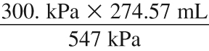 =
d. 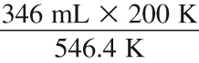 =
5. Round the following measurements to three significant figures.
a. 22.77 g
b. 14.62 m
c. 9.3052 L
d. 87.55 cm
e. 30.25 g
PROBLEMS Write the answer on the line to the left. Show all your work in the space provided.
6. A pure solid at a fixed temperature has a constant density. We know that:
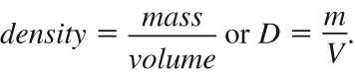
a. Are mass and volume directly proportional or inversely proportional for a fixed density?

b. If a solid has a density of 4.0 g/cm³, what volume of the solid has a mass
of 24 g?
7. A crime-scene tape has a width of 13.8 cm. A long strip of it is torn off and measured to be 56 m long.
a. Convert 56 m into centimeters.
b. What is the area of this rectangular strip of tape, in cm²?

